Validation for Metal

Name_______________________________

|  |  |  |
| --- | --- | --- |
| Name of metal |  | Mark |
| Symbol |  |  |
| What other metals are in the same group (column) of the periodic table as your metal? |  | 1 |
| Mercury is the only metal that is liquid at room temperature. Mercury has a density of 13.6g/cm3. Will your metal float or sink in liquid mercury? Give a reason for your answer |  | 2 |
| Will mercury float or sink in pure water? Give a reason for your answer. |  | 2 |
| Gold has a market value of about $38,000 per kilo. Does one kilo of your metal cost more than a kilo of gold? |  | 1 |
| What is the formula for Hydrogen iodide? |  | 1 |
| Write the word equation for your metal reacting with hydrogen iodide. |  | 1 |
| Write a balanced formula equation for your metal reacting with hydrogen iodide. |  | 2 |
| Is your metal an Alkali metal, Alkaline Earth Metal, Transition Metal or Rare Earth Metal? |  | 1 |
| State two characteristics that all metals share. |  | 2 |
| Iron reacts with oxygen gas to form iron oxide (Fe2O3). If your metal were to react with oxygen to form a metal oxide what would be the formula for the oxide of your metal. |  | 1 |
| When your metal forms an ion, does it loose or gain electrons. State the number of electrons lost or gained by one atom of the metal. |  | 1 |
| Aluminium has a density of 2.7 g/cm3. Gold has a density of 19.3 g/cm3. Zinc has a density of 7.14 g/cm3. Draw a table that compares the density of these 3 metals and your metal. Draw this onto the graph grind on the next page. | | 5 |
| Total | | /20 |



Positive ions

1+ Charge 2+ Charge 3+ Charge

H1+ hydrogen Mg2+ magnesium Al3+ aluminum

Na1+ sodium Ca2+ calcium Fe3+ iron (III)

K1+ potassium Ba2+ barium Cr3+ chromium (III)*

Cu1+ copper (I) Zn2+ zinc

Ag1+ silver Cd2+ cadmium

NH41+ ammonium Hg2+ mercury (II)

Li1+ lithium Cu2+ copper (II)

Pb2+ led (II)

Fe2+ iron (II)

Negative ions

1– Charge 2– Charge 3– Charge

F 1‑ fluoride O2‑ oxide PO43‑ phosphate

Cl 1‑ chloride S2‑ sulfide P3‑ phosphide

Br 1‑ bromide SO42‑ sulfate N3‑ nitride

I 1‑ iodide SO32‑ sulfite

NO3 1‑ nitrate CO32‑ carbonate

NO2 1‑ nitrite

**Common acids**

|  |  |
| --- | --- |
| Name | Formula |
| Hydrochloric acid | HCl |
| Sulphuric acid | H2 SO4 |

**Periodic Table**

[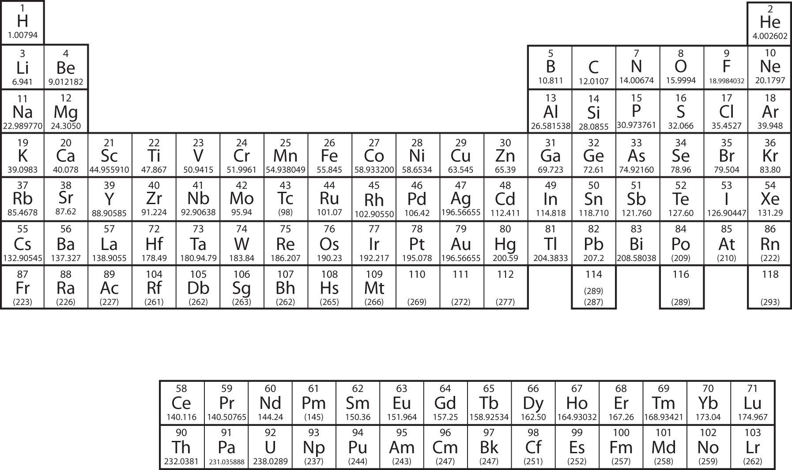](http://www.google.com.au/url?sa=i&rct=j&q=simple+periodic+table+of+elements&source=images&cd=&cad=rja&docid=laRrA9PpttqalM&tbnid=P6GyLZl6WUNMtM:&ved=0CAUQjRw&url=http://2012books.lardbucket.org/books/introductory-chemistry/section_12_04.html&ei=wXixUeyqIoLHkwXVtoC4Bw&psig=AFQjCNGPXwsEpHOmDP09g6Y0Fm0tHa6rUg&ust=1370671674403245)